Android studio

Android studio provides the fastest tools for building applications on every type of android device. It contains code editing, debugging, performance tooling and flexible build system.

Features

Code and iterate faster than ever :

* Instance run
* Intelligent code editor
* Fast and feature rich emulator

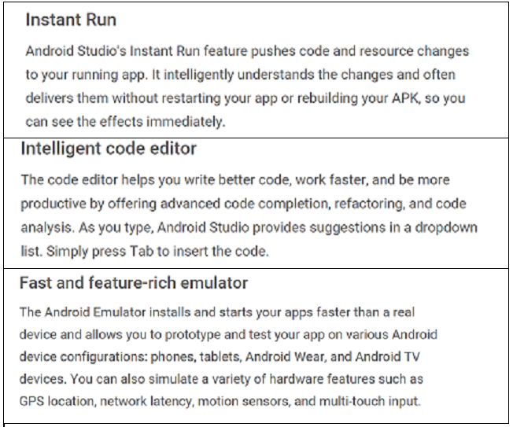

Config build without limits :

* Designed for teams
* Optimized for all android devices
* Robust and flexible build system

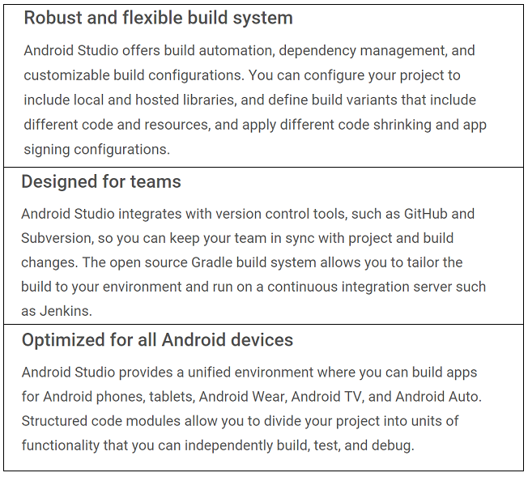

Code with confidence :

* Linteligence
* Testing tools and frameworks
* Code templates and sample applications

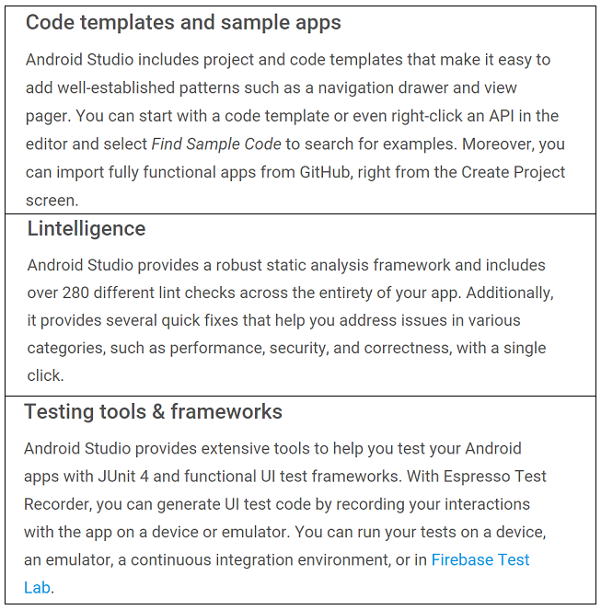

Create rich and connected applications

* C++ and NDK support
* Firebase and cloud integration

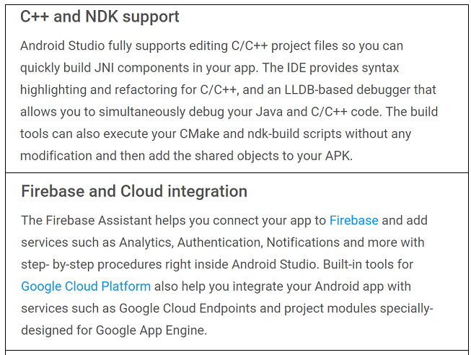

Eliminate tiresome tasks :

* Layout editor
* APK analyser
* Vector asset studio

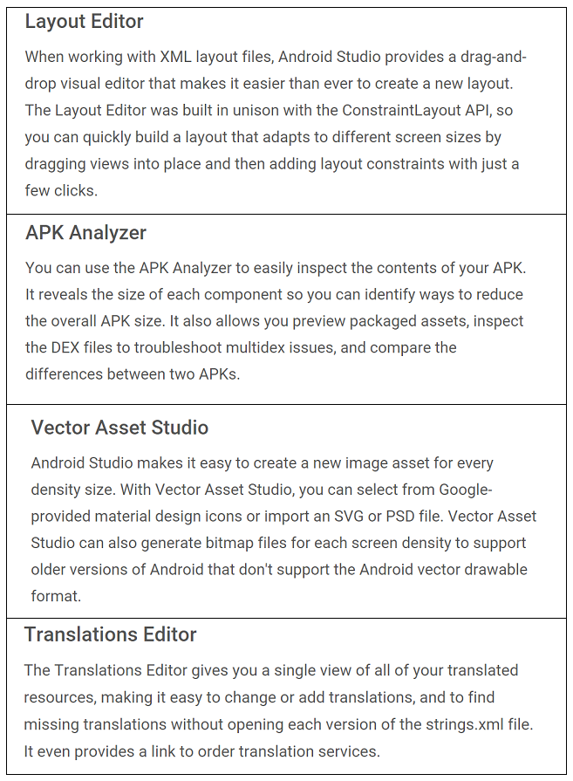

I also spent some time using android studio myself. I followed two tutorials :

The first was a simple android counter that a user would click and it would keep count of how many times it was clicked.

The tutorial can be found here : <https://www.youtube.com/watch?v=gyHpBrBZle8>

The finished Application can be found here : <https://github.com/LorcanHbermingham88/androidCounterApp>

The second tutorial was a android step counter. The counter used the phone's sensors to measure the amount of steps that were taken.

The tutorial can be found here : <https://www.youtube.com/watch?v=CNGMWnmldaU>

The finished application can be found here : <https://github.com/LorcanHbermingham88/step_monitor>

Ionic 2

Ionic was started in 2013, the aim was to make a better way for web developers to use their existing skill set to build applications for application stores.

Over the last two years millions of developers from nearly every industry around the world have built over 1.2 million mobile applications with ionic.

Ionic CLI :

* The cli is a tool that provides a number of helpful commands to the developer

Components :

* Components are reusable UI elements
* They are made up of HTML, CSS, JavaScript
* They adapt to the platform on which the application is running

Theming :

* Styles that get applied to an application

Angular

* This is the framework ionic 2 uses for building client applications in HTML and JavaScript or a language like TypeScript
* Angular applications are composed of by HTML templates with Angularized markup, writing component classes to manage those templates adding application logic

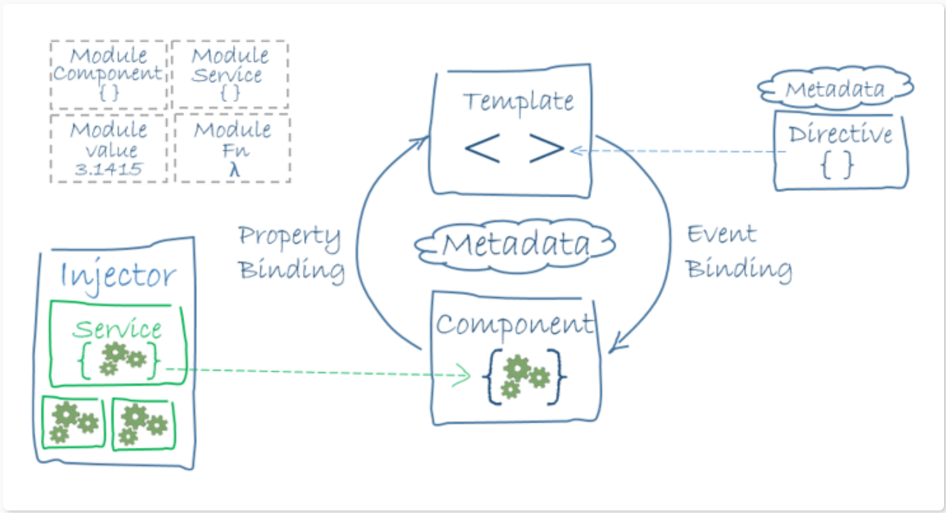

Android : <https://developer.android.com/studio/index.html>

Ionic 2 : <http://ionic.io/2>

Angular : <https://angular.io/docs>